# PeopleSafe Main Screen Job Aid

High Level Overview

Main Screen - Participant Detail Section Tips

Main Screen - Viewing Client Program Offerings

Main Screen - Search Criteria Section Tips

Main Screen - All Tab Claim History Section Tips

Main Screen - Mail Order Tab Claim History Section Tips

Prescription History Screen Search Tips

Main Screen - Miscellaneous Navigational Button Tips

Identifying a Claim Adjustment 

Related Documents

**Description****:** Examples and tips for locating information in PeopleSafe via the Main Screen.

|  |
| --- |
| High Level Overview |

The Main Screen is the initial screen accessed after opening a member’s account in PeopleSafe.

* Within the Main Screen there are multiple tabs, buttons, hyperlinks, and sections that allow the user to access additional information within the member’s account. Not all buttons and links are used by Commercial CCRs – these are **not** addressed in the explanations below.
* Refer to illustration below and the following sections within this document for further details.

**Main Screen Example:**

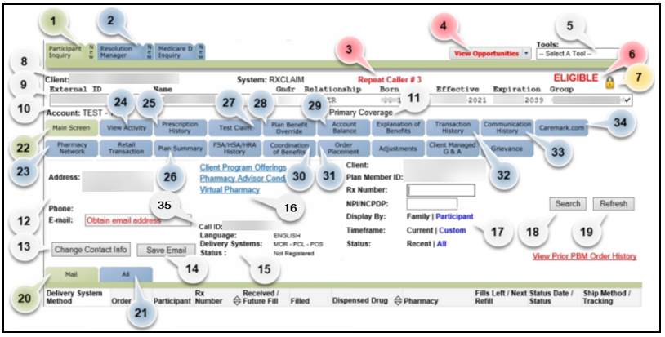

**Notes:**

* The blue buttons turn green when selected. In the screenshot above, the green Participant Inquiry, Main Screen, and Mail Tab buttons show that the main Member record and Mail Orders are being viewed.
* When a Member uses the IVR system to indicate the reason for their call, the appropriate button will turn yellow to prompt action.

**Example:** If the Member states “check price of medication” the Test Claim button will highlight in gold.

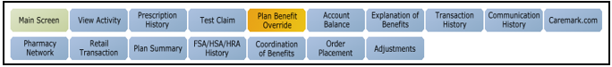

* In some cases the IVR system will default to the appropriate tab.

**Example:** If the Member states “order my medications”, the system will default to the Order Placement screen.

**Eligibility Section:**

1. **Participant Inquiry:** Clicking this button before/between calls, populates the [Search Screen (027257)](https://thesource.cvshealth.com/nuxeo/thesource/#!/view?docid=57660ff2-9cac-4009-8267-7231e754b512). Clicking this button while within a Member’s PeopleSafe record will result in a return to the Main Screen. Clicking the NEW portion of this button will result in leaving the Member profile and returning to the Search screen.
2. **Resolution Manager:** This button populates the [Resolution Manager (029980)](https://thesource.cvshealth.com/nuxeo/thesource/#!/view?docid=3438a8ea-9ad1-4c4b-b710-57dab144493c) screen, to create or edit RM Tasks. Clicking the NEW portion of this button creates a new Resolution Manager Task.
3. **Repeat Caller Indicator:** This indicates how many times the caller has called in, or how many times the profile has been accessed, on the same day.

**Note:** When exiting to search for alternate or inactive profiles, choose Disposition> RESEARCH, Source of Contact> MEM/DEP, and Form of Contact: **IN HOUSE, RESEARCH** to avoid the activity being logged as a Repeat Call.

1. **View Opportunities:** This drop-down menu presents the [Health Engagement Engine (HEE) Index (106189)](https://thesource.cvshealth.com/nuxeo/thesource/#!/view?docid=c9265c2b-45b5-4bcf-b292-ba06e9860ef1) opportunities which may be available to the caller. The “View Opportunities” text will flash if there is an active opportunity which needs to be presented.
2. **Tools:** The “Select A Tool” drop-down menu has many different database searches available. The function most frequently used by Customer Care is the [PeopleSafe - Find a Prescriber Tool (018702)](https://thesource.cvshealth.com/nuxeo/thesource/#!/view?docid=6c70a19a-da0d-4879-84d0-ab2c3f23b39b).
3. **Eligibility Indicator:** Indicates ELIGIBLE (**Example:** The profile is active.) or NOT ELIGIBLE (**Example:** The profile is inactive.).
4. **Authorization Padlock:** This icon indicates that the Member has an [Authorized Representative (007394)](https://thesource.cvshealth.com/nuxeo/thesource/#!/view?docid=970803bb-c0d8-4180-ae71-a8feab415b65) on file. Click the padlock to view the information.
5. **Client Code and Plan Sponsor Name:** Used to identify the Member’s Company/Plan Sponsor and specific plan design information for the member. The Client Code is the CIF number.
6. **Family Drop-Down Menu:** Displays the External ID, Name, Gender, Relationship to Cardholder, Effective & Expiration Dates, and Group Name for each individual on the profile. Select the person that the call is in reference to (not necessarily who is calling).
7. **Account:** Identifies the group or sub-plan within the overall Client/Plan (**Example:** PPO).
8. **Primary/Secondary Coverage Indicator:** For purposes of Coordination of Benefits (COB) between two insurance carriers, this indicates if the current record is the Primary or Secondary payer. See the Eligibility section of the CIF to determine if this can be changed by Caremark or the Plan Sponsor/Client.

**Contact Information:**

1. **Contact Information:** Displays the address, phone and email for the Member selected in the Family Drop-Down Menu.
2. **Change Contact Info****:** This is used to access the [Contact Info Input Screen (027674)](https://thesource.cvshealth.com/nuxeo/thesource/#!/view?docid=918203d3-2d76-4044-b2d9-0ced0504d471) for the Member selected in the Family Drop-Down Menu.
3. **Save Email:** Click this button to save after entering a new email on the Main Screen.
4. **Language/Delivery Systems/Status:** Shows the default language, the Member’s Caremark.com registration status (if applicable to the specific client), and the available Delivery Systems.

* MOR = Mail Order
* PCL = Paper Claims
* POS = Point of Sale/Retail

1. **Client Specific Options:**
2. **Client Program Offerings:** Overview of plan details. Refer to [PeopleSafe - Client Program Offerings Comparison Guide (027425)](https://thesource.cvshealth.com/nuxeo/thesource/" \l "!/view?docid=b6e05522-5955-4535-ad00-01d20dbe09e8).

**Example:** MChoice, Auto Refill, etcetera.

1. **Pharmacy Advisor Conditions:** Refers to the [Health Engagement Engine (HEE) – View Opportunities (022708)](https://thesource.cvshealth.com/nuxeo/thesource/#!/view?docid=c2732a43-0453-4dab-a245-537dbe97d1e0).
2. **Virtual Pharmacy:** The Regional Order Center/Pharmacy Warehouse that fulfills the Member’s mail order prescriptions.

**Search Functions:**

1. **Search Options:** The search boxes display differently depending on whether the MAIL or ALL tabs are selected, but the overall functionality is the same.

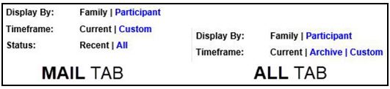

* 1. **Display By: Family | Participant****:** Shows all claims for everyone on the plan by default or click “Participant” to see only the specific member selected in the Family drop down Menu.
  2. **Timeframe: Current | Custom (Mail Tab) -**  **Timeframe: Current | Archive | Custom (All Tab):**  Shows the most recent claims by default. Clicking “Custom” can narrow it down to a certain date range. When viewing the All tab, clicking “Archive” expands the records to show all claims on file, not just the most recent.
  3. **Status: Recent | All****:**  Shows the most recently shipped Mail Orders by default. Clicking “All” includes orders that were canceled, rejected, or reversed orders including those that were successfully sent, and expands the time frame from the past three months to all claims on file.

1. **Search Button:** Used in conjunction with the Search Options (Refer to 17).
2. **Refresh Button:** This button is used to refresh the screen to show any new or updated information or claims. When clearing Rx or NPI/NCPDP search fields, be sure to click Refresh to return to all records.
3. **Mail Tab:** Displays all Mail Orders (MOR).
4. **All Tab:** Displays all claim history; including Mail Orders, Retail/Point of Sale transactions, and Paper Claims.

**Navigation Tabs:**

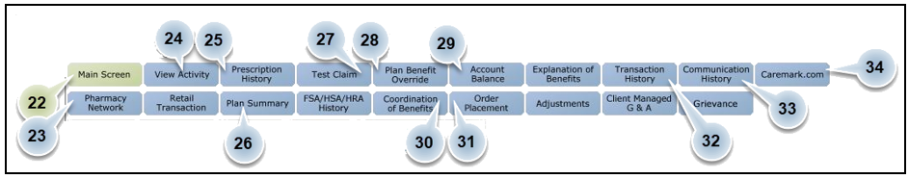

**Note:** Buttons not normally used by Commercial Customer Care are not included in this key.

1. **Main Screen:** The default page view in PeopleSafe. This screen can also be accessed by clicking “Participant Inquiry.”
2. **Pharmacy Network:** Displays a geographical list of all in-network pharmacies and indicates which network level each pharmacy is on.

**Example:** MChoice, Retail 90, Vaccine.

**Note:** If the Member’s address is a PO Box, the address portion of the search function will need to be removed to work properly. Refer to [Retail Pharmacy Details and Locator (023842)](https://thesource.cvshealth.com/nuxeo/thesource/#!/view?docid=6c209183-6f8f-4e38-9647-7952ab652433).

1. **View Activity:** Call history log which displays past user’s notes, captured activity, and RM tasks that have been created within a 90-day timeframe (date range can be adjusted). Refer to [Viewing Activity in PeopleSafe and Compass Interactions (046145)](https://thesource.cvshealth.com/nuxeo/thesource/#!/view?docid=318e35f6-03d7-4aeb-92c1-8bf24ca8d851).
2. **Prescription History:** A log of previously submitted claims from selected delivery method within a 3-month date range (date range can be adjusted).
3. **Plan Summary:** Copay structure for retail/mail specific to member’s selected plan. Check general Copays, Coinsurance, Plan limitations.
4. **Test Claim:** Check drug cost and coverage information via [Test Claims (004573)](https://thesource.cvshealth.com/nuxeo/thesource/#!/view?docid=59c4e7fa-4a87-43c4-89cd-5d4f8c6c3421).
5. **Plan Benefit Override:** Enter/review current [Overrides (024671)](https://thesource.cvshealth.com/nuxeo/thesource/#!/view?docid=f075340f-87ec-41b3-bdeb-16422d0fed0e) and check status of Prior Authorizations and [Appeals (007339)](https://thesource.cvshealth.com/nuxeo/thesource/#!/view?docid=cd7126d2-19b7-4743-913c-8e9dd7329c08).
6. **Account Balance:** Check Accumulation details. Refer to [Accumulators or Accumulations (Deductible, Account Balance, MOOP, MAB) (064862)](https://thesource.cvshealth.com/nuxeo/thesource/#!/view?docid=a22d707e-1643-448e-9968-f44d1a828038).

**Example:** OOP, MOOP, DED, MAB

1. **Coordination of Benefits:** Enter alternate insurance information for COB on this screen if the Member provides it, and the CIF allows it. Refer to [Claims Coordination of Benefits (COB) Mail Order Only (004599)](https://thesource.cvshealth.com/nuxeo/thesource/#!/view?docid=7471cab3-a401-4828-8b07-838b4c8fdd55).
2. **Order Placement:** Utilize this button for [Prescription (Rx) Refill/Renewal (Order Placement) (004628)](https://thesource.cvshealth.com/nuxeo/thesource/#!/view?docid=932f2f09-4581-4c2c-861d-5145ad7ab97a), [New Rx Request (058827)](https://thesource.cvshealth.com/nuxeo/thesource/#!/view?docid=a1443f4f-499e-442c-be11-fd2b207bf86c), [Auto Refill Program (ARP) (022387)](https://thesource.cvshealth.com/nuxeo/thesource/#!/view?docid=89a5f1e4-2fea-404a-a5f8-6e50549eb3de) and to [Transfer Rx Index (004726)](https://thesource.cvshealth.com/nuxeo/thesource/#!/view?docid=db939cc1-1f5e-44de-89df-985827477553).
3. **Transaction History:** Check balance owed, process payments, view transactions, and [Payment Finding (Locate) a Payment (024758)](https://thesource.cvshealth.com/nuxeo/thesource/#!/view?docid=f68cdde2-ea7f-4f11-bb7d-a1f80f29dc4c).
4. **Communication History:** [PeopleSafe - Obtaining an Email Address and Managing Messaging Platform Alerts (027674)](https://thesource.cvshealth.com/nuxeo/thesource/#!/view?docid=918203d3-2d76-4044-b2d9-0ced0504d471) history of automated outbound calls/letters sent to member.
5. **Caremark.com:** If the Member has registered on a Caremark.com page, this button displays the Member’s profile. If not, the option to send a [Quick Registration links (012470)](https://thesource.cvshealth.com/nuxeo/thesource/#!/view?docid=c90a32de-421f-42c2-8d5c-69ce36571418) via email or text message is available.

**Note:** Not all Clients use Caremark.com. See CIF for participation details.

35. **Call ID:**  Useable for Behavior Analytics and IMPACT coaching purposes.

**Notes:**

* Copy Call ID when swiveling from PeopleSafe to Compass and document in Case Notes within Compass.
* This is **not** a call reference number or provided to the caller for any reason.

Top of the Document

|  |
| --- |
| Main Screen - Participant Detail Section Tips |

**Participant Detail Section Example:**

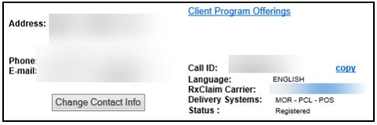

Refer to the following **Participant Detail Section** tips:

* **Address -** Primary address of member selected.
* **Phone -** Phone number of member selected.
* **E-mail -** E-mail of member selected.
* **Change Contact Info -** Change/update member information and CMP alerts.
* **Client Program Offerings -** Programs offered by the client for the member.
* **Virtual Pharmacy (ROCC)** – address that member can send mail order form to receive prescription through Mail Order if applicable.
* **Delivery Systems -** Delivery systems available to member (MOR – Mail Order/PCL – Paper Claims/POS – Retail)
* **Status -** Caremark.com registration status of member selected.
* **Call ID -** Useable for Behavior Analytics and IMPACT coaching purposes.

**Note:**  Copy **Call ID** when swiveling from PeopleSafe to Compass and document in **Case Notes** within Compass. This is **not** a call reference number or provided to the caller for any reason.

Top of the Document

|  |
| --- |
| Main Screen - Viewing Client Program Offerings |

The Client Program Offerings hyperlink on the PeopleSafe **Main** screen provides descriptions for those clients who participate in programs such as:

* Retail 90
* Auto Refill and Auto Renewal
* Pharmacy Advisor
* Maintenance Choice
* Preferred Pharmacy
* Compound Network
* Cost Saver Program

**Note:** Other choices may be available based on client options.

If a program is listed on this screen, then the member is eligible to participate.

**Note:** Not all programs are displayed on this screen. For a comprehensive list of programs refer to [Client Programs Work Instruction Index (061276)](https://thesource.cvshealth.com/nuxeo/thesource/#!/view?docid=0609eb74-869f-422a-ba76-d5c3a5b4da40).

Select the **Client Program Offerings** hyperlink (PeopleSafe **Main** Screen).

**Result:** PeopleSafe opens pop-up window revealing program description.

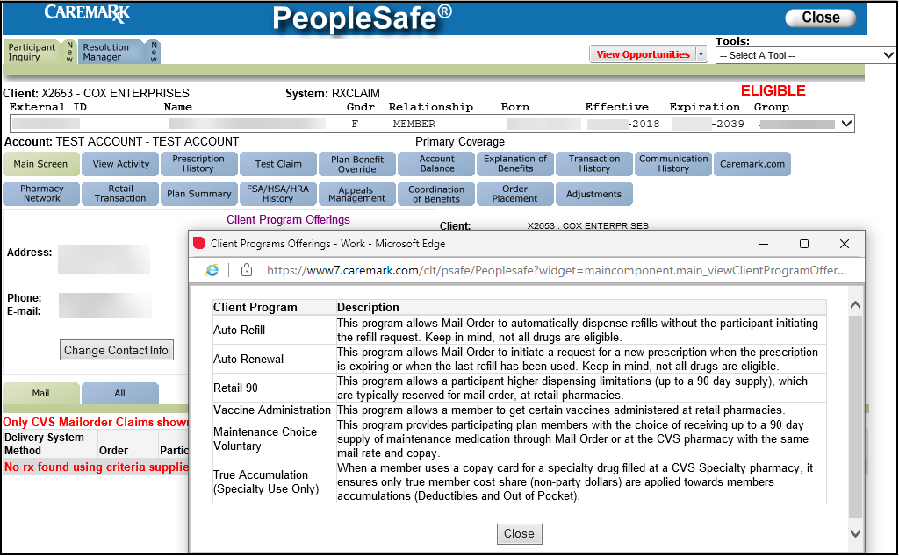

Top of the Document

|  |
| --- |
| Main Screen - Search Criteria Section Tips |

**Search Criteria Section Example:**

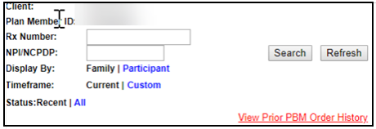

Refer to the following **Search Criteria Section** tips:

* **Client -** Name of the client of the profile selected.
* **Plan Member ID -** ID# of member selected.
* **Rx Number -** To locate a specific prescription number on the Main Screen of PeopleSafe, enter the prescription number in the Rx Number field. Only this prescription number will then display; to search for additional prescription numbers delete the number previously entered into this field.

**Notes:**

* For mail order prescriptions, click the **Mail** tab, change the **Status** to “All” and then click Search.
* For retail prescriptions, click the **All** tab, change the **Status** to “Archive” and then click Search.
* **NPI/NCPDP -** To locate a specific pharmacy on the Main Screen of PeopleSafe, enter the NPI/NCPDP in the NPI/NCPDP field and then click Search. Only this pharmacy will then display. To search for additional pharmacies, delete the NPI/NCPDP previously entered into this field.
* **Display By -** Ability to see Family (all members on the account) or Participant (only prescriptions shown for member selected on family drop down menu).
* **Timeframe -** Current shows most recent prescription. The archive shows older prescriptions on member’s account. Custom allows users to specify the time frame in which to search.
* **Status -** Shows Recent or All for prescription history.

Top of the Document

|  |
| --- |
| Main Screen - All Tab Claim History Section Tips |

All Tab Claim History Section:

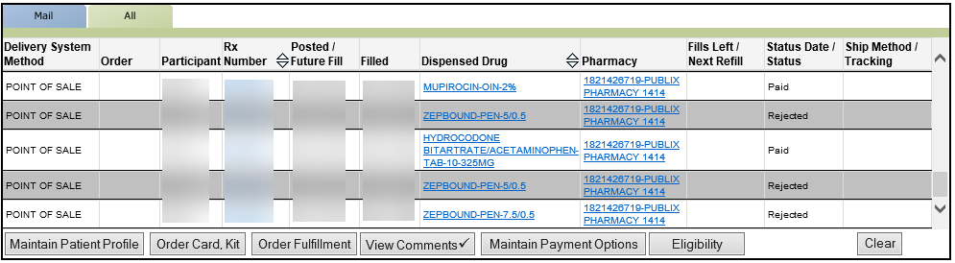

From left to right, the columns display the following information:

* **Delivery System Method** – Will display POINT OF SALE, MAIL ORDER or PAPER CLAIM.
* **Order** – This column will be blank for all delivery methods under the **All** Tab. To see order numbers for Mail Order (MOR) click the Mail tab.
* **Participant** – Indicates which member on the account was written the prescription.
* **Rx Number** – Provides Prescription number. Click the link to access the Prescription Detail screen. Lists can be arranged in numerical order by using up and down arrows.
* **Posted/Future Fill** – Date the Retail Pharmacy ran the prescription through insurance to get a PAID claim; Future Fill date shows when the prescription can be run through insurance.
* **Filled** – Date the Retail Pharmacy filled the prescription.
* **Dispensed Drug** – Name, dosage, and strength of prescription; list can be arranged in alphabetical order by using up and down arrows. Click the link to view medication information.
* **Pharmacy** – Name and NPI of dispensing pharmacy; click link to access pharmacy information.
* **Fills Left/Next Refill** – Refers only to Mail Order prescriptions held by Caremark. This column will be blank when using the All tab, as Caremark does not have access to that Retail Rx data. Select the Order Placement tab to view the most up-to-date number of refills remaining.
* **Status Date/Status** – Shows status of the prescription at the Retail Pharmacy.

**Note:** PAID does **NOT** mean the prescription was picked up and paid for, PAID means that the prescription was ACCEPTED through the insurance.

* **Ship Method/Tracking** – This is blank when the prescription is filled through Retail Pharmacy as the prescription was physically picked up at a Retail Pharmacy location.

Top of the Document

|  |
| --- |
| Main Screen - Mail Order Tab Claim History Section Tips |

**Mail Order Tab Claim History Section Example:**

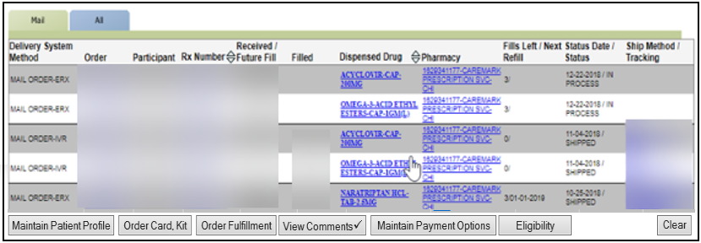

From left to right, the columns display the following information:

* **Delivery System Method** – How the prescription(s) were placed/sent in.

Refer to table to see the different Method and Description:

|  |  |
| --- | --- |
| **Delivery System Method** | **Description** |
| MAIL ORDER-IVR | Authenticated caller placed refill/renewal through an INBOUND call using our automated IVR system. |
| MAIL ORDER-IVR IMPORT | Authenticated caller agreed to refill through our OUTBOUND automated IVR system (we called them). |
| MAIL ORDER-ERX | Prescription sent by E-scribe from prescriber’s office. |
| MAIL ORDER-FAX | Prescription faxed in by prescriber’s office. |
| MAIL ORDER-MAIL | Prescription was mailed in by Member/Dependent or prescriber’s office. |
| MAIL ORDER-WEB | Refill/Renewal placed through Caremark.com. |
| MAIL ORDER-CSR | Refill/Renewal placed by a Customer Service Representative (CSR). |
| MAIL ORDER-PHONE | Prescription was called in verbally via FastStart. |
| MAIL ORDER-SMS | Refill/Renewal place via SMS TEXT. |

* **Order** – Provides Order Number; click link to access the Order Status screen.
* **Participant** – Indicates which member on the account the prescription was written for.
* **Rx Number** – Provides Prescription number. Click the link to access the Prescription Detail screen. Lists can be arranged in numerical order by using up and down arrows.
* **Received/Future Fill** – Date the prescription was received by our system (Will show as top date or as the only date). If two (2) dates are shown, the second date on the bottom is the **Future Fill date** (when the prescription will begin processing).
* **Filled** – Date the Mail Order Pharmacy (MOR) filled the prescription.
* **Dispensed Drug** – Name, dosage, and strength of prescription; list can be arranged in alphabetical order by using up and down arrows. Click the link to view medication information.
* **Pharmacy** – Name and NPI of dispensing pharmacy; click link to access pharmacy information.
* **Fills Left/Next Refill** – Displays number of refills remaining for that specific Mail Order Prescription, and when the prescription is available to be filled again.
* **Status Date/Status** – Date the prescription was processed and the status of the order.
* **Ship Method/Tracking** – The method the prescription/order was shipped, click link to view detailed tracking information. (**Example:** USPS or UPS website).  
  **Note:** If clicking the link does **not** work: Copy and paste this number into the carrier’s tracking site. For USPS Tracking Numbers, remove all hyphens and extra blank spaces.

Top of the Document

|  |
| --- |
| Prescription History Screen Search Tips |

The **Sort by** **dropdown** menu displays the following information in descending or ascending order:

* Sort claims by **Fill Date**
* Sort claims by **Drug name alphabetically** A to Z
* Sort claims by **Pharmacy & Prescriber**
* Display **Paid**, **Rejected** or **Reversal**
* **Delivery systems available to view by clicking on the radio button next to:** Adjudicated Claims, Mail Order, POS, CVS Retail and Specialty

**Note:** Additional information within the prescription history Screen not available for sorting.

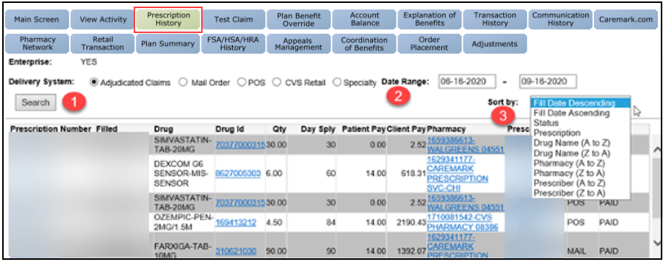

Top of the Document

|  |
| --- |
| Main Screen - Miscellaneous Navigational Button Tips |

**Miscellaneous Navigational Button Example: (Displays at the bottom of the PeopleSafe Main Screen)**



Refer to the following **Miscellaneous Navigational Button** tips:

* **Maintain Patient Profile** – View, add, or edit certain changes to the member’s profile. Use this button when there is a padlock on the account to view POA (Power of Attorney) or Authorized Representative information.
* **Order Card, Kit** – To send an entire benefit kit or just an ID card (for select Clients – if Caremark handles ID cards) check CIF before offering to send.
* **Order Fulfillment** – Request literature to be sent to the member.

**Examples:** Order form, paper claims form, SOC – Financial Statement of Cost, etcetera.

* **View Comments** – View notes left by other departments and to access High Priority Comments. This is used to notate member profiles when appropriate.
* **Maintain Payment Options** – Add, edit and/or delete a payment method from a member’s profile.
* **Eligibility** – Basic eligibility information for the member.
* **Clear** – Button should not be used by CCRs.
* **Capture Activity** – Logs all activities performed while in a member’s profile.



**Note****:** Use this button to capture call details during as well as at the end of the call to ensure all Activity Codes are recorded. If using this button to capture activities or add notes during calls, click the “Save” button to return to the PeopleSafe record. At the end of the call, after accessing Capture Activity and adding any applicable notes, click “Save & Exit Account” to return to the PeopleSafe search screen for the next call. Do not use the “Close” button at the top right of the screen, as this will not capture any call activity.

* **Warm Transfer -** Button usually does not display in PeopleSafe and should not be used.
* **Save Call Data –** Use when conferencing or transferring a call to transfer the data regarding the caller.

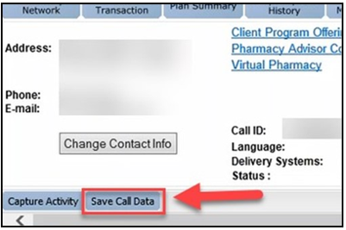

Top of the Document

|  |
| --- |
| Identifying a Claim Adjustment |

To identify if a claim has received an adjustment, the following Adjustment Indicator(s) are revealed in the **“Status”**field for RxClaim.

The following are adjustments types that display:

* Adjustment – Paid
* Adjustment – Rejected
* Adjustment – Reversal

To view additional information regarding the adjustment:

|  |  |
| --- | --- |
| **Step** | **Action** |
| **1** | Select the **prescription number**. |
| **2** | Select the **settlement code** from the lower left hand corner to view additional information regarding the adjustment type. |

Top of the Document

|  |
| --- |
| **Related Documents** |

[Log Activity / Capture Activity Codes (005164)](https://thesource.cvshealth.com/nuxeo/thesource/#!/view?docid=bdac0c67-5fee-47ba-a3aa-aab84900cf78)

[Customer Care Abbreviations, Definitions and Terms Index (017428)](https://thesource.cvshealth.com/nuxeo/thesource/#!/view?docid=c1f1028b-e42c-4b4f-a4cf-cc0b42c91606)

Top of the Document

Not To Be Reproduced or Disclosed to Others Without Prior Written Approval

**ELECTRONIC DATA = OFFICIAL VERSION – PAPER COPY = INFORMATIONAL ONLY**